**Code commit**

* AWS CodeCommit is a fully-managed source control service that makes it easy for companies to host secure and highly scalable private Git repositories.
* CodeCommit eliminates the need to operate your own source control system or worry about scaling its infrastructure.
* You can use CodeCommit to securely store anything from source code to binaries, and it works seamlessly with your existing Git tool.

**Code Deploy**

* AWS CodeDeploy is a service that automates code deployments to any instance, including Amazon EC2 instances and instances running on-premises.
* AWS CodeDeploy makes it easier for you to rapidly release new features, helps you avoid downtime during application deployment, and handles the complexity of updating your applications.
* You can use AWS CodeDeploy to automate software deployments, eliminating the need for error-prone manual operations, and the service scales with your infrastructure so you can easily deploy to one instance or thousands.

**Code pipeline.**

* AWS CodePipeline is a continuous delivery service for fast and reliable application updates.
* CodePipeline builds, tests, and deploys your code every time there is a code change, based on the release process models you define.
* This enables you to rapidly and reliably deliver features and updates.
* You can easily build out an end-to-end solution by using our pre-built plugins for popular third-party services like GitHub or integrating your own custom plugins into any stage of your release process.
* With AWS CodePipeline, you only pay for what you use. There are no upfront fees or long-term commitments.

Theory apart. Lets implement it. Here what I am going to do is that, I am going to host a website on my EC2 instances, by using all this services. I am going to host the application across multiple servers. So let dive deep into it.

**Prereq.**

* AWS Account.
* Configure AWS CodeCommit. You can follow steps that are given in <http://docs.aws.amazon.com/codecommit/latest/userguide/setting-up-ssh-unixes.html>
* “Hello World” application, whether it is .py, .rb or .html.
* Virtual box with linux installed in it.

**CodeCommit.**

My application is stored in index.html. I am going to commit it into CodeCommit. Here you can use all git commands. I just create a “webapp” directory and a index.html page inside the directory.

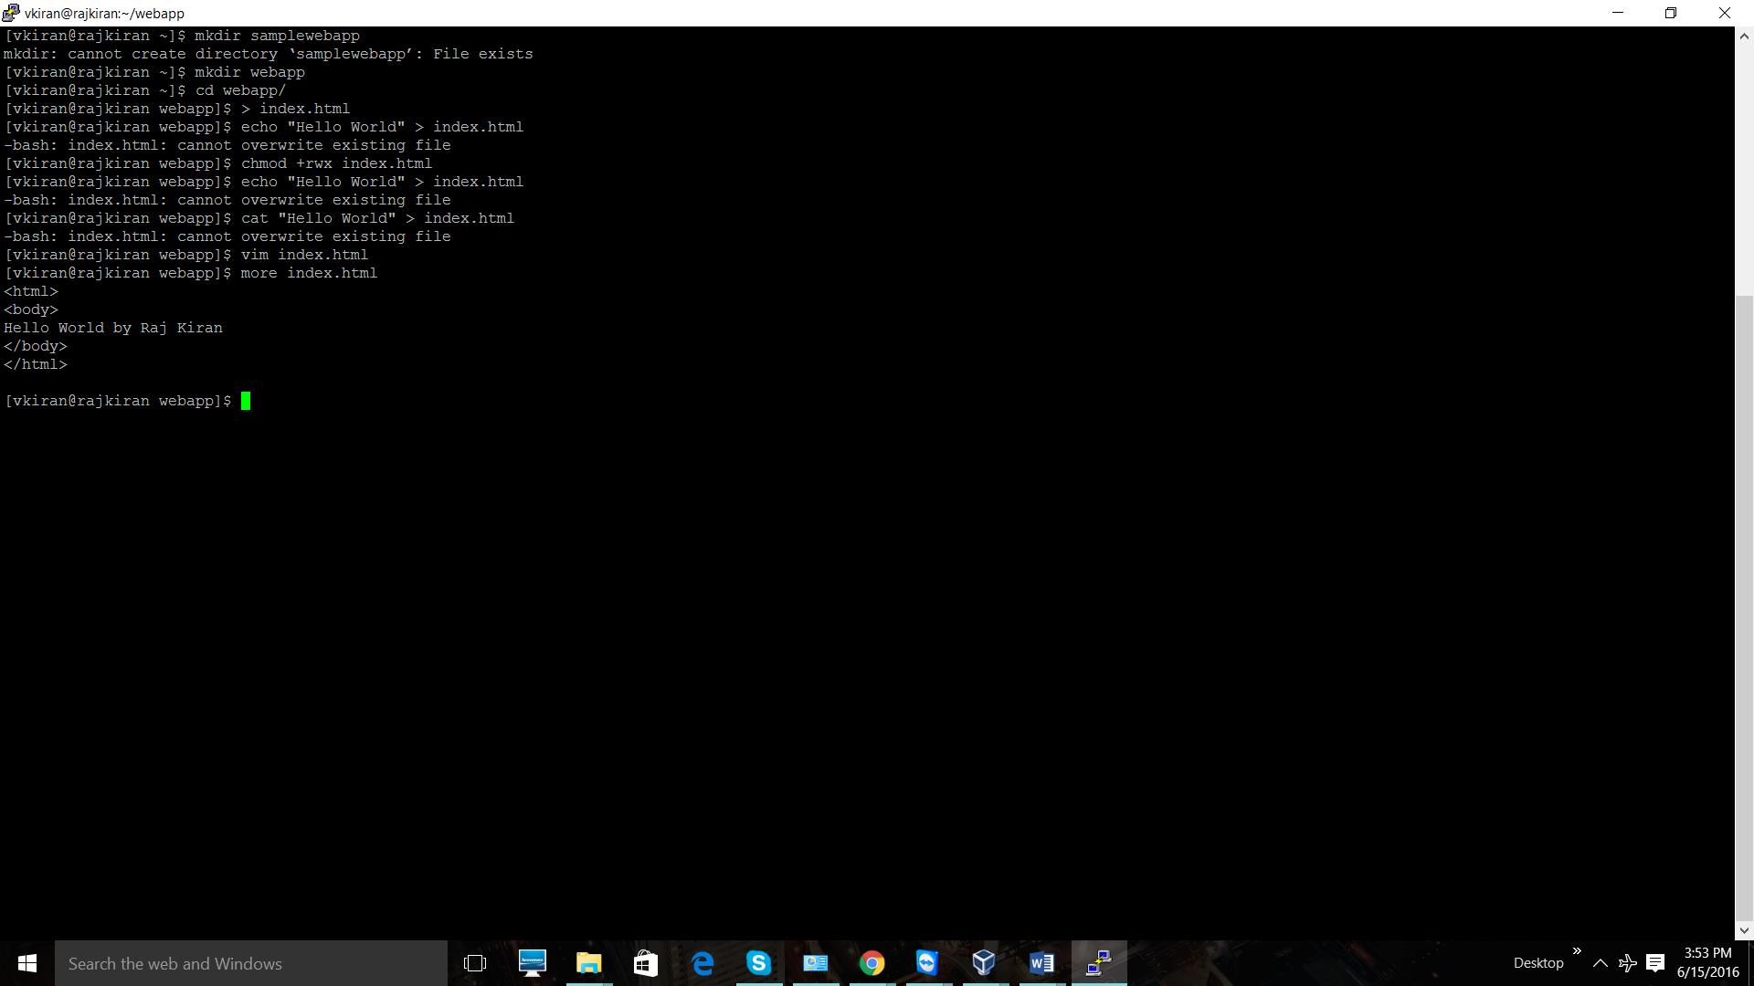

Let us create a empty repo in Code commit. Got to your AWS account and select Code commit service and get started.

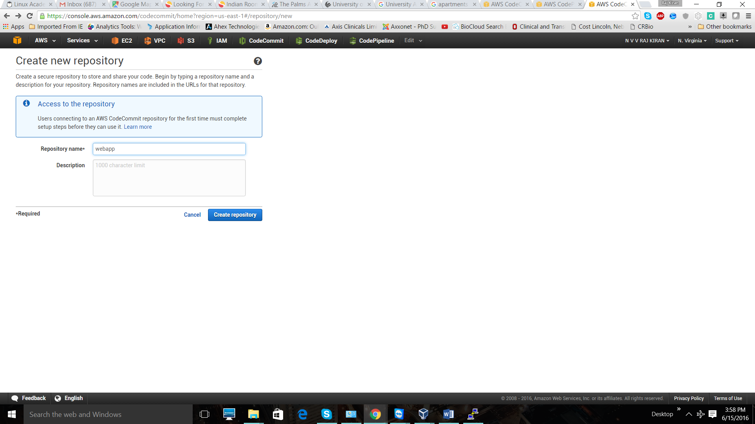

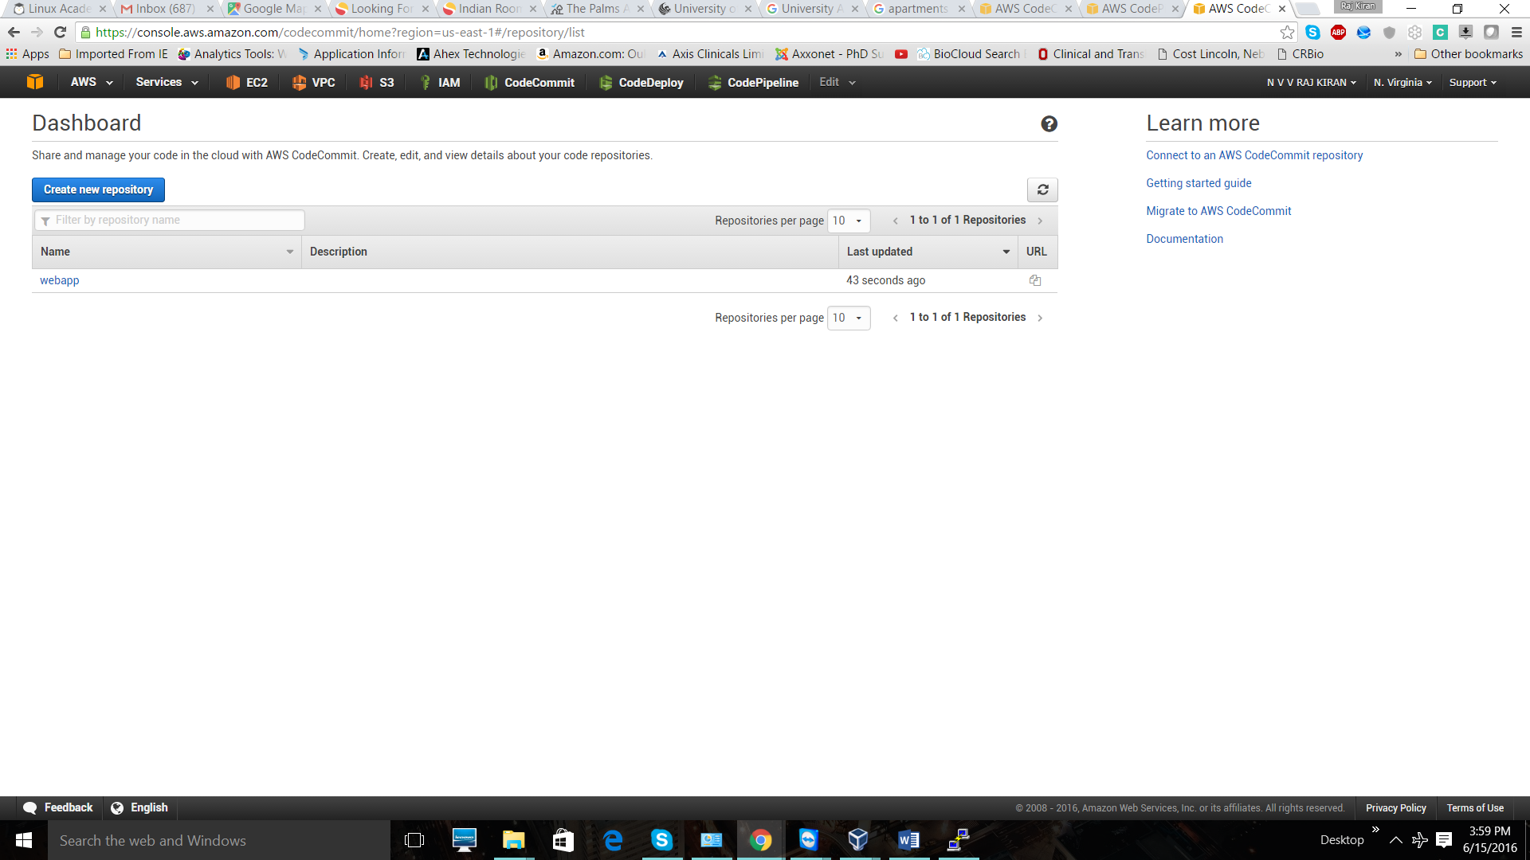

Go into the repo and get the URL of the webapp. As I configure my CodeCommit using SSH. I am hereby using ssh based url. Copy the url.

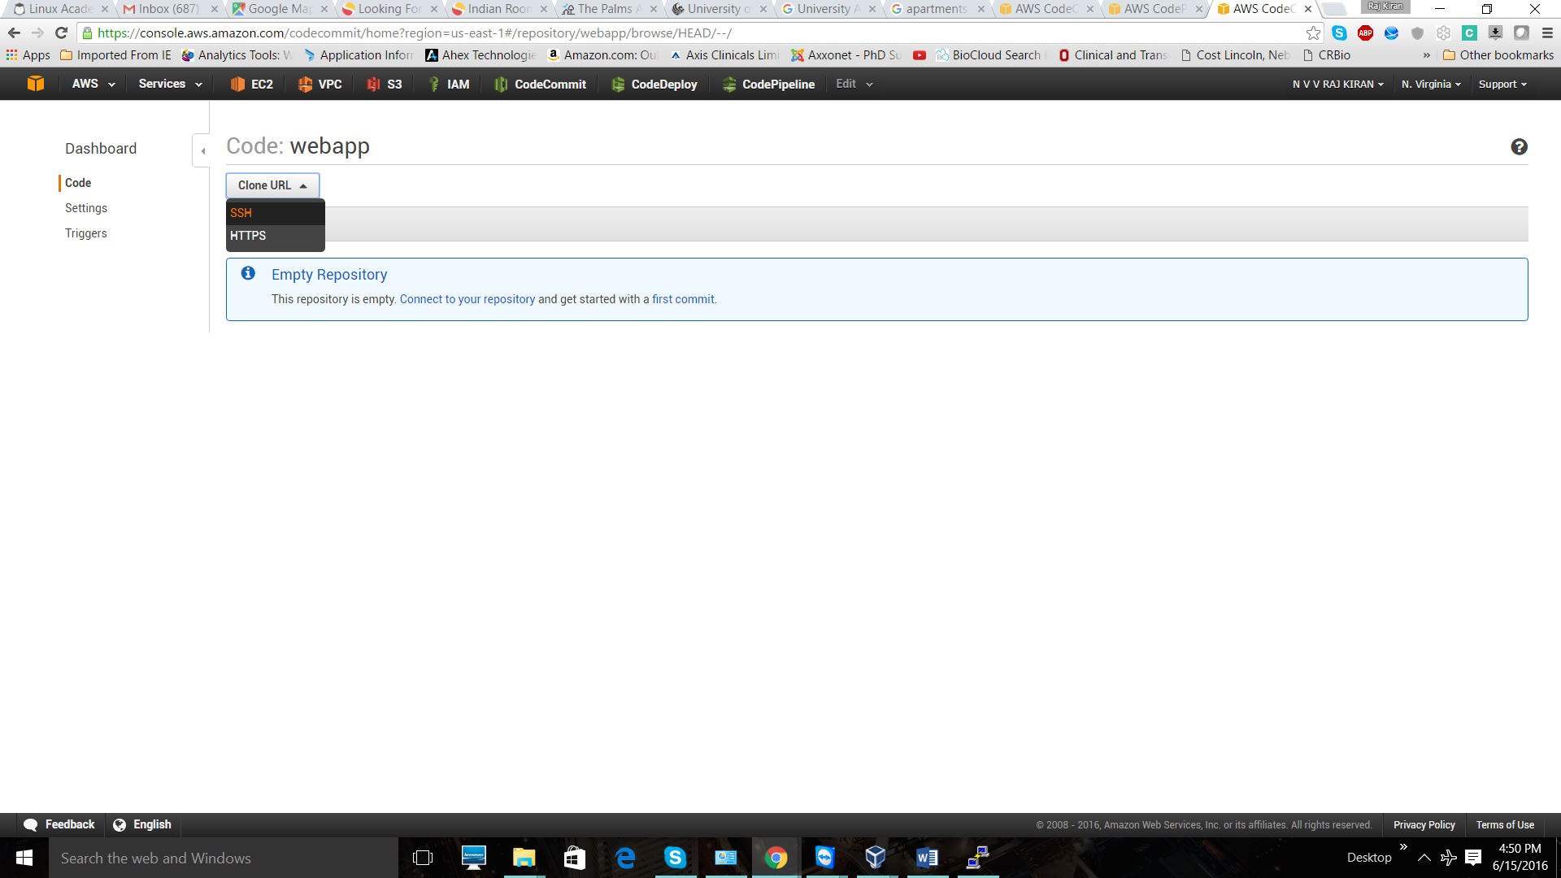

Go to your local and initialize your “webadd” repo. 🡪 **git init .**

Next step is to make use of the SSH URL and add our project. Command you need to run is

**git remote add origin sshurl**

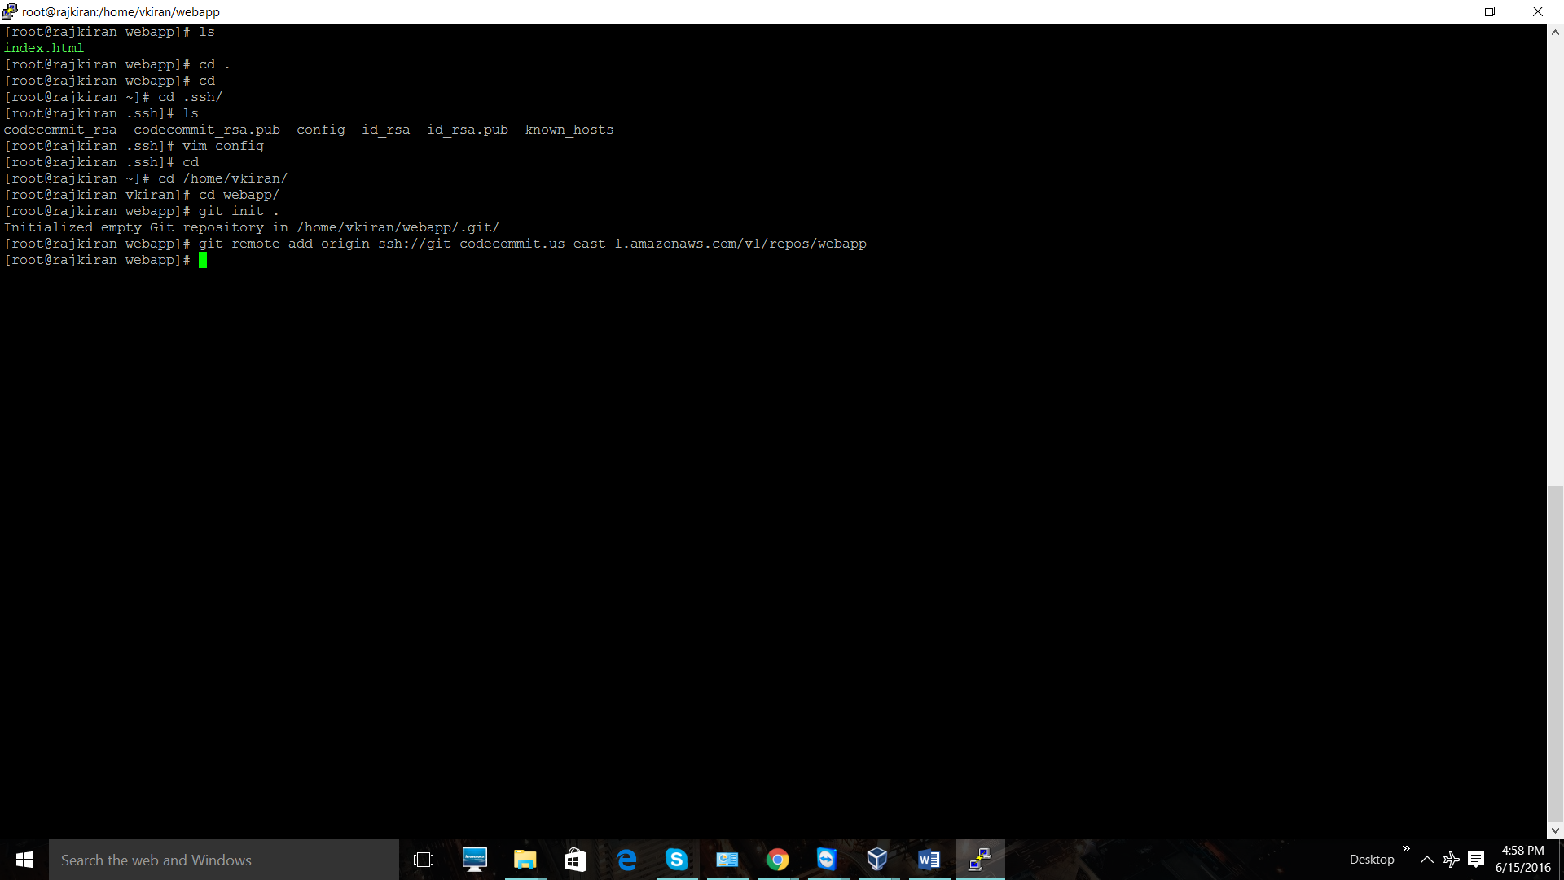

Once you add the URL. You need to following steps to add file to the codecommit repo.

* git add .
* git commit –m “message”
* git push origin master

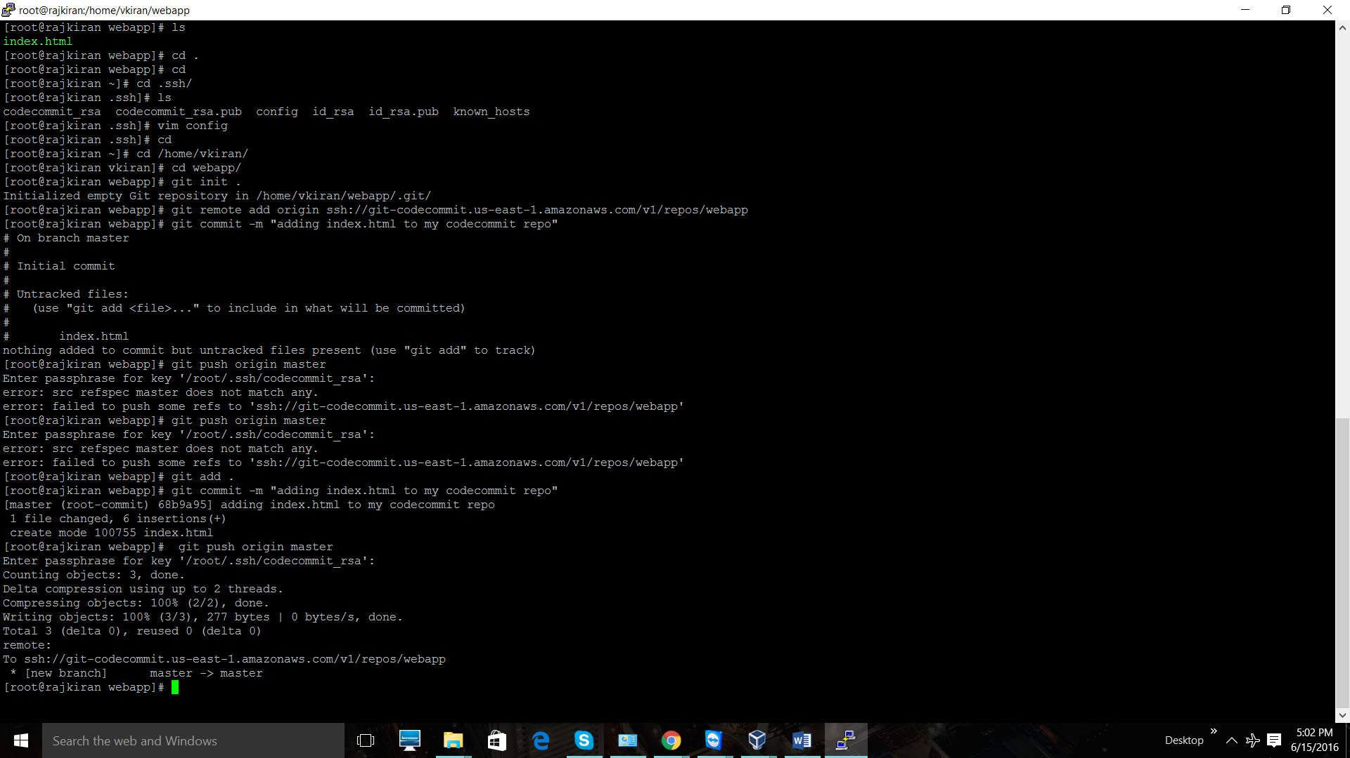

Now you must see the index file in your “code commit” repo. Go to AWS comsol and navigate through webapp repo.

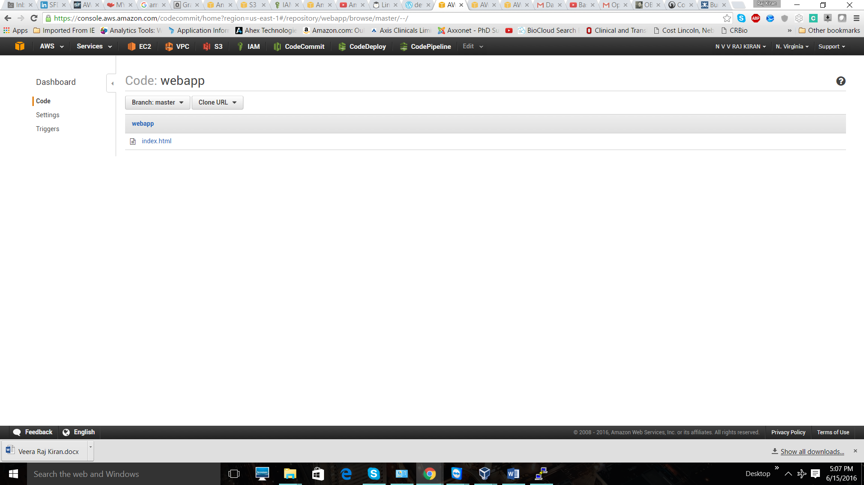

In same way try to create a repo and upload all files in **project folder**. The project folder contains of “aspec” file which define our environment. It is the key file to supply configuration details to codedeploy. You just navigate through all file and understand what we defined in “aspec file”.



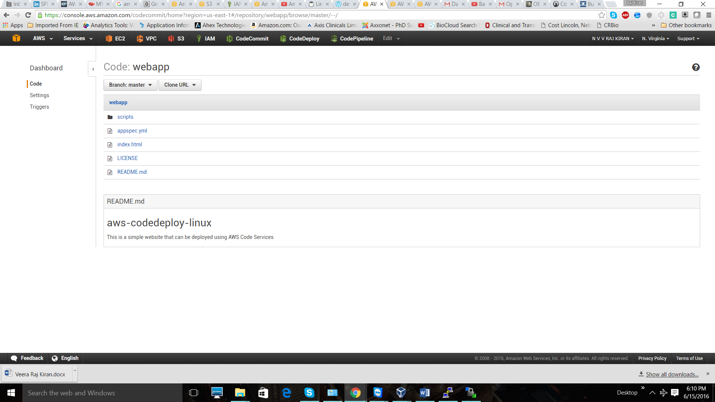

“appspec” file is important to define environment. It includes which file to deploy, what server to be run, and ports that are to be installed. Even I included few hooks that runs different scripts that before install, after-install etc.

**Step 2.**

Now let us deploy this web page across two instances using codepipleline and codedeploy. I am going to create two instances and install Codedeploy agent on top of two instance.

First step is to create two roles.

**“CDinstanceRole”,** role to permit communication between instances and codedeploy. Go to IAM polices and create a new role.

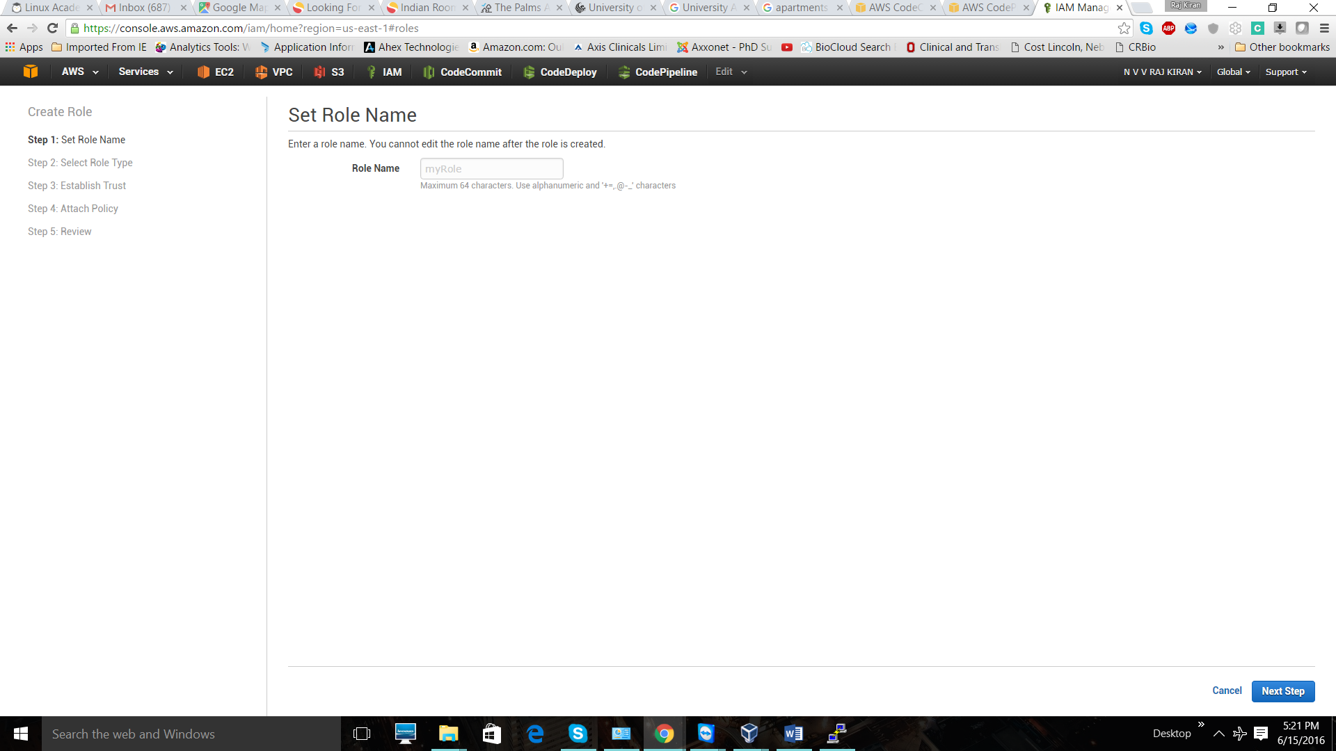

Select “AWS EC2 service role”

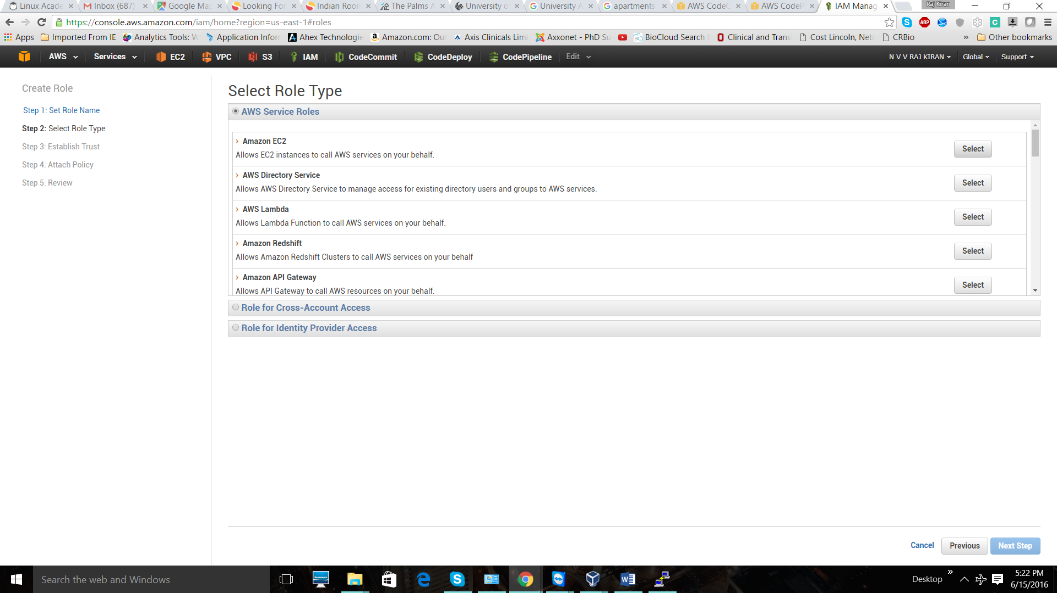

Attach “AmazonEC2RoleforAWSCodeDeploy” policy to the role. Create the role.

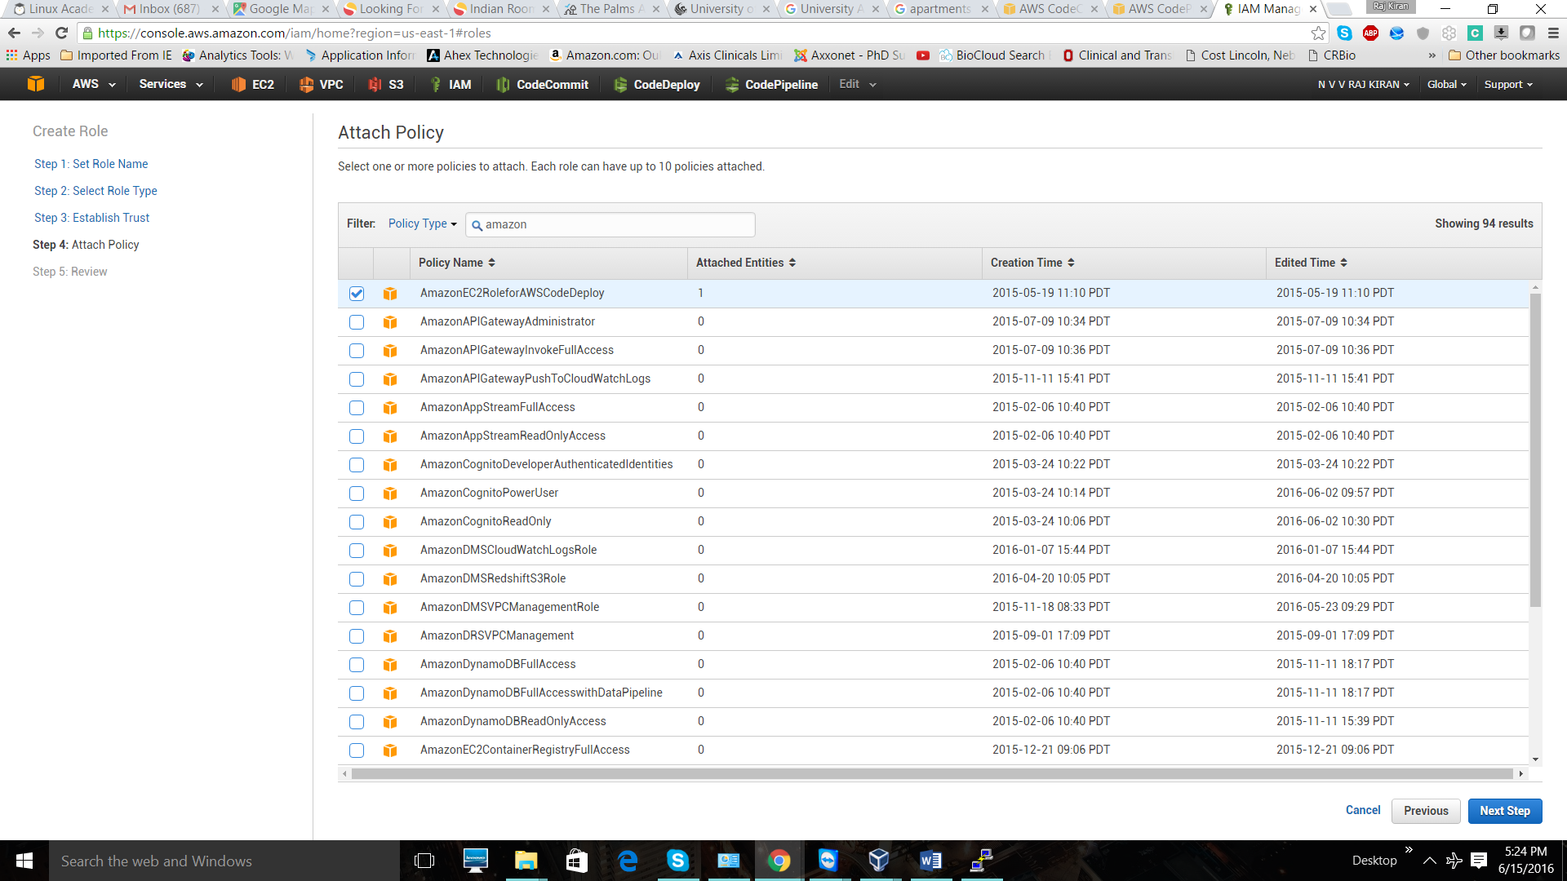

**Second Role .** In this role we are just creating a role that we are going to attach to our AWSCodeDeploy application. Such that this role will allow user to use AWSCodeDeploy service. Create a new role with name “CDserviceRole”



Select the “**AWS CodeDeploy**” service role. And create the role. We are going to use those two role in following steps.

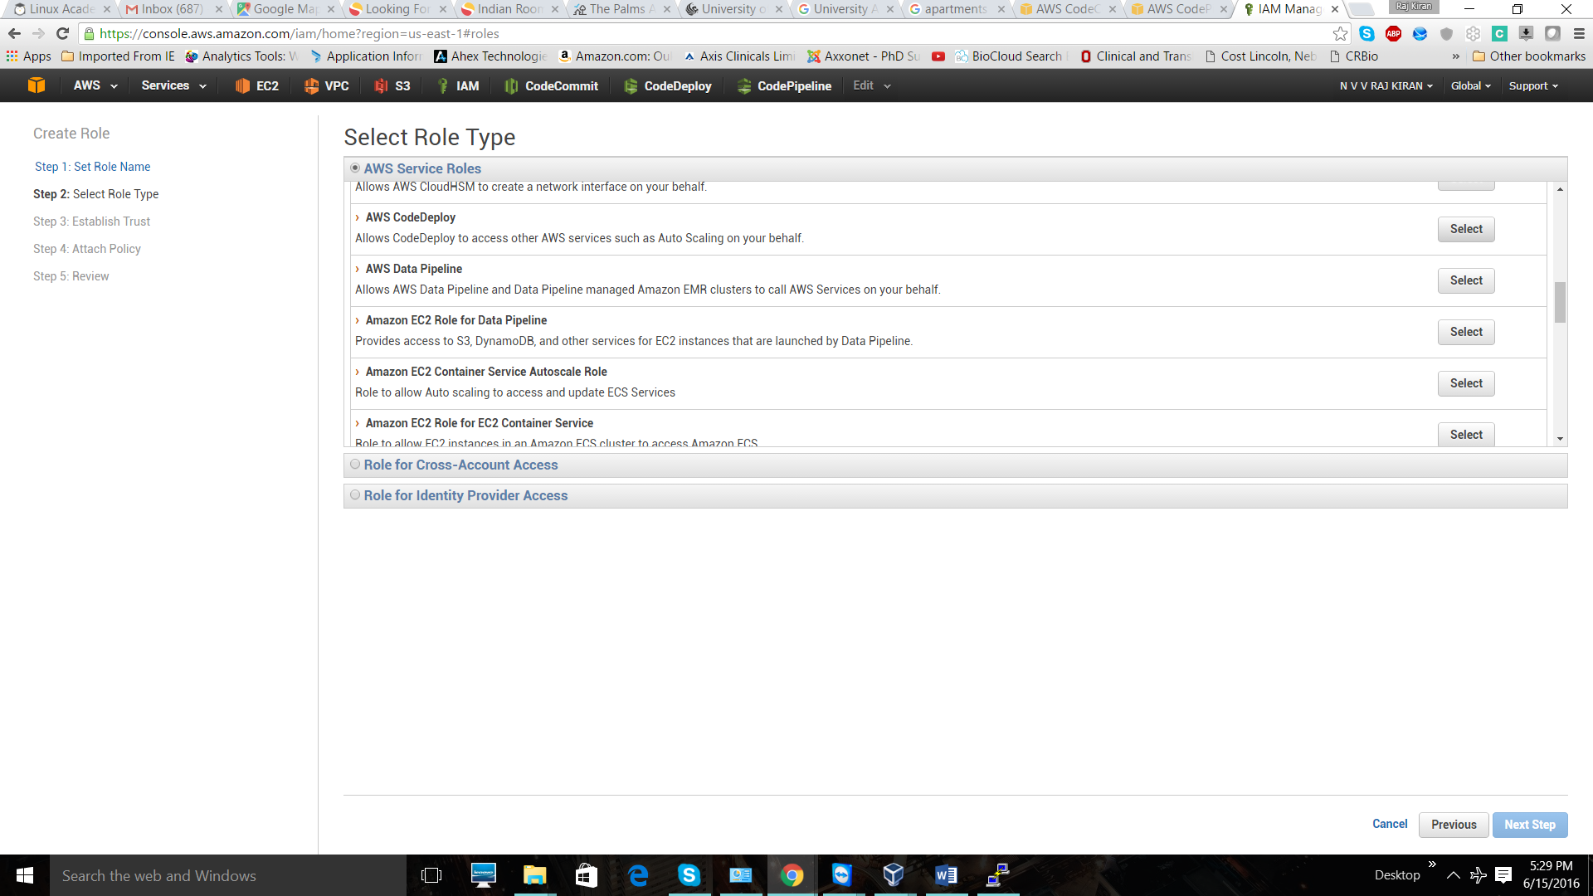

Now we are having two role that we created.

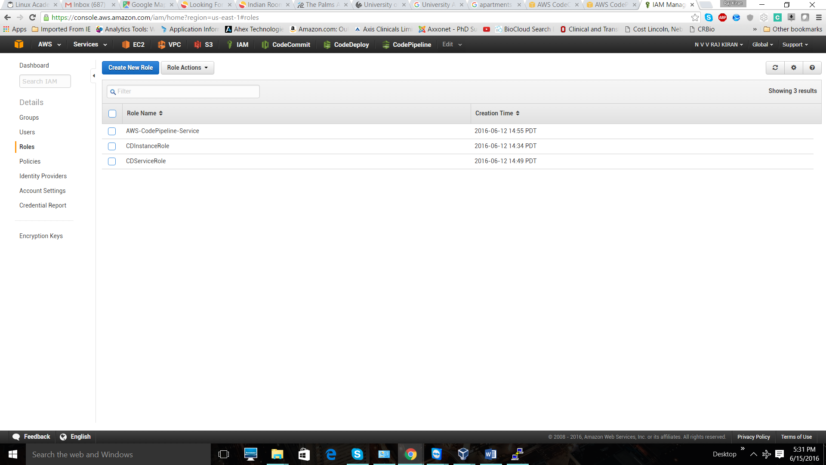

**Step 3.**

Let us bootstrap two instances and attach “CDInstanceRole” to those. Go to AWS EC2 instance service and create t2 instance. In configure instance section select the IAM role you create. And give the number of instance that you want to bootstrap.

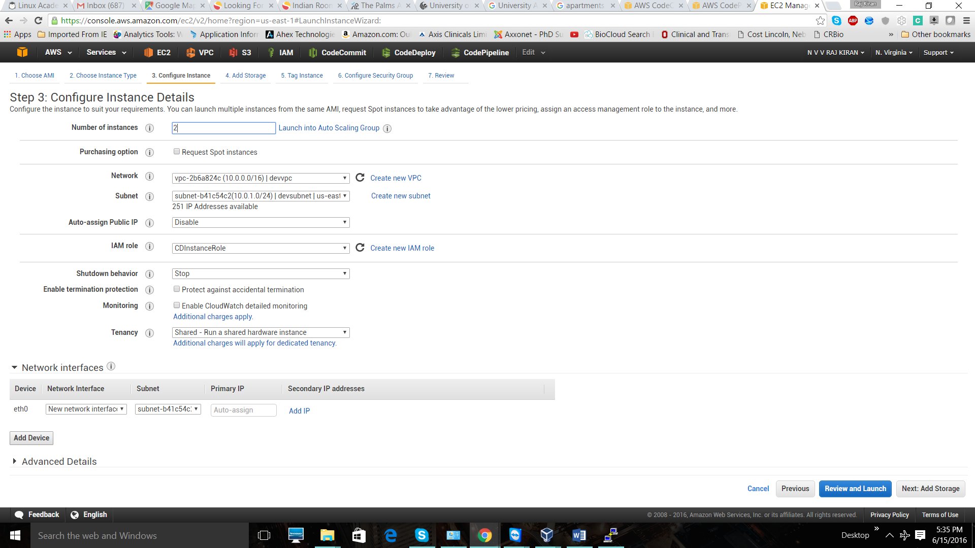

Create those instances by following come steps. Make sure that you are allowing the “SSH” and “HTTP” protocols is open to you.Next step is to associate an elastic IP to those instances.

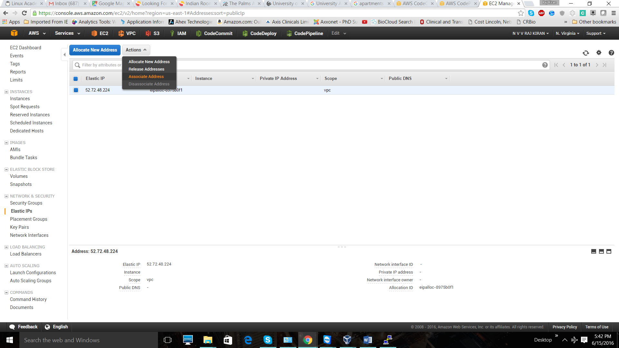

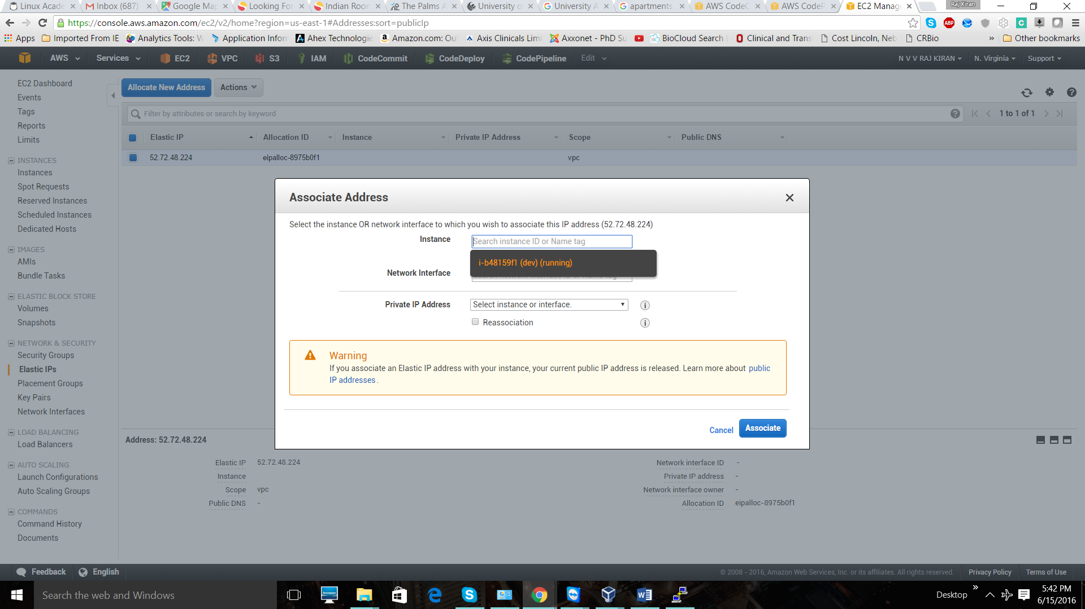

Next step is to login into the instances and install the AWS Deploy agent.

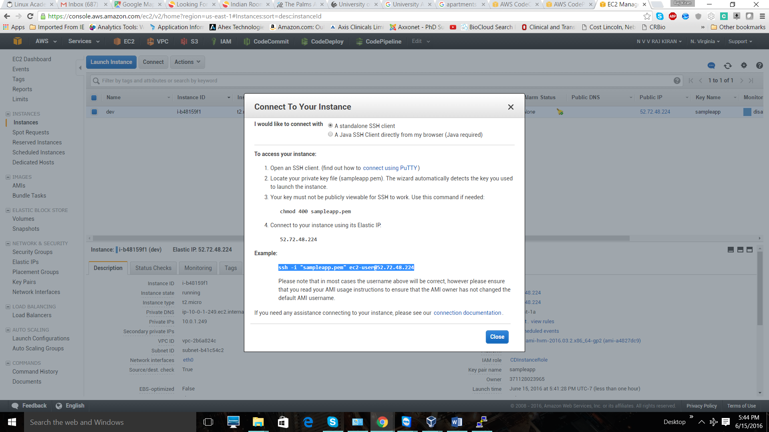

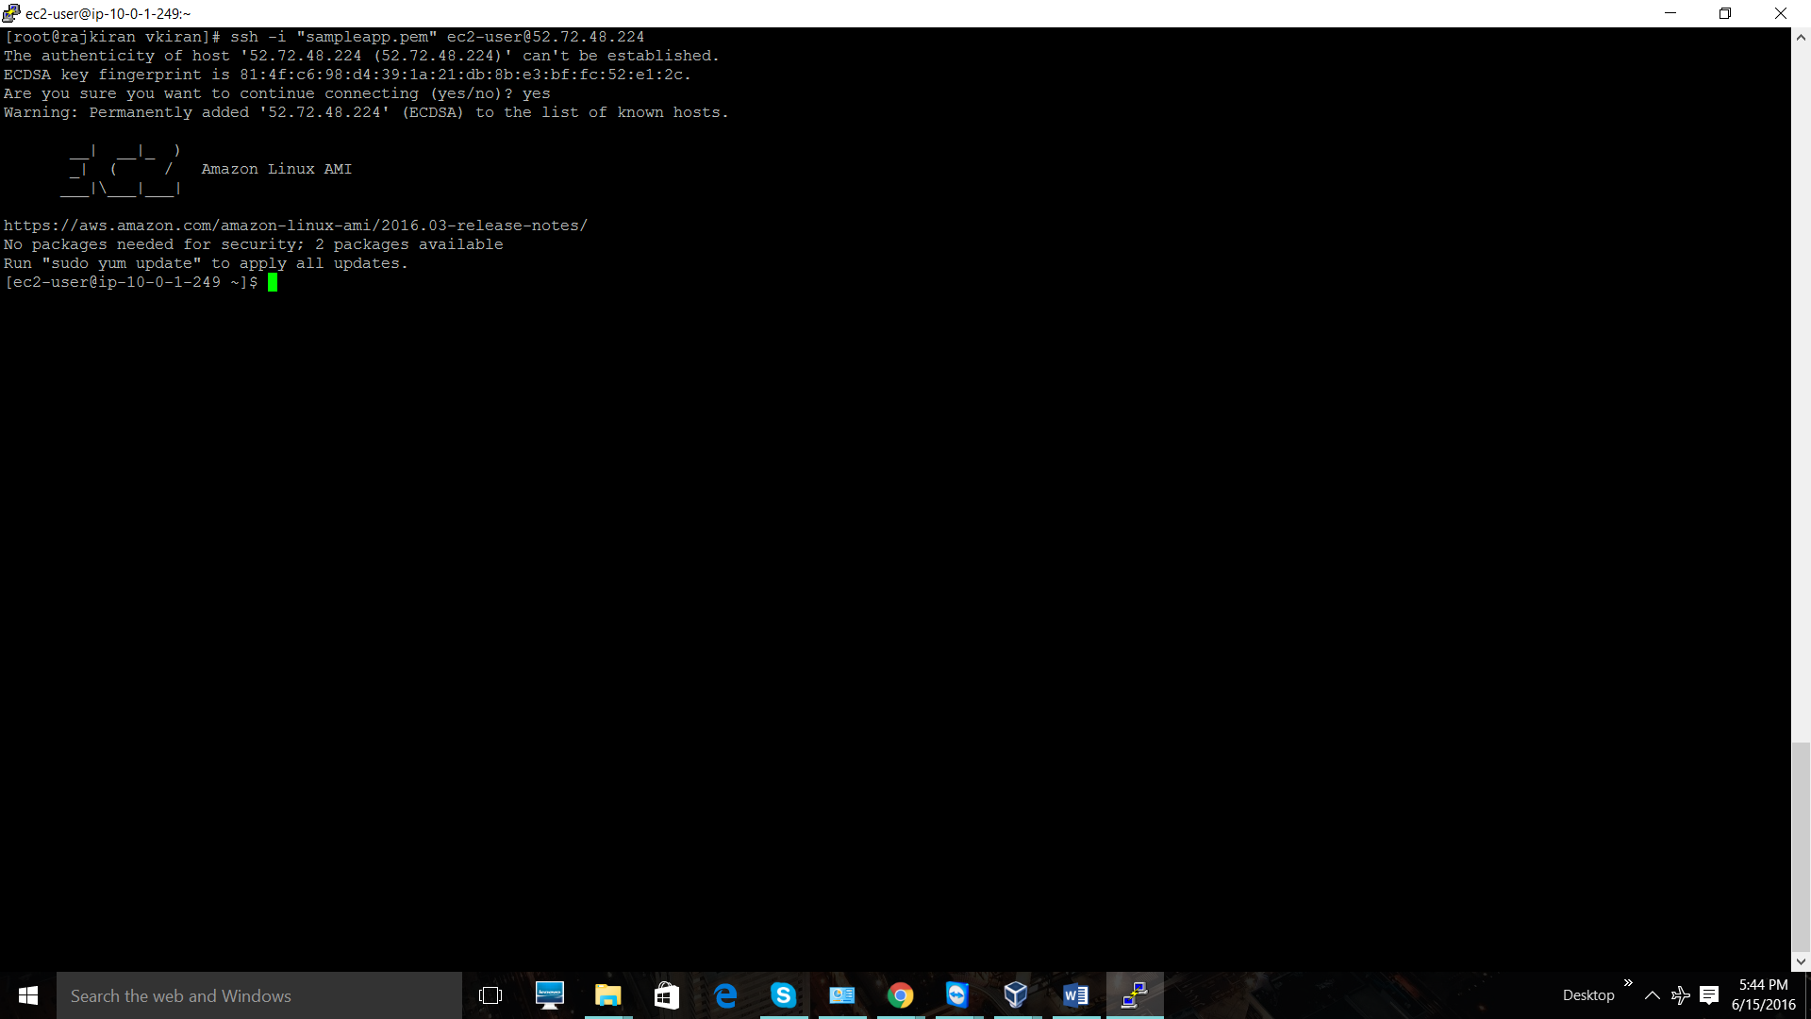’

Now you can see I am into the EC2 instance. Let us install AWS CodeDeploy agent in this server. Steps to be followed are (ref: <http://docs.aws.amazon.com/codedeploy/latest/userguide/how-to-run-agent-install.html>)

**sudo** yum update

**cd** /home/ec2-user

wget [https:// aws-codedeploy-us-east-1.s3.amazonaws.com/latest/install](https://bucket-name.s3.amazonaws.com/latest/install) (Because I am in US East)

**chmod** +**x** ./install

sudo ./**install** **auto**

Once you are done with above steps check whether CodeDeploy agent is installed or not. Command to check is

sudo service codedeploy-agent status

You should see following result.

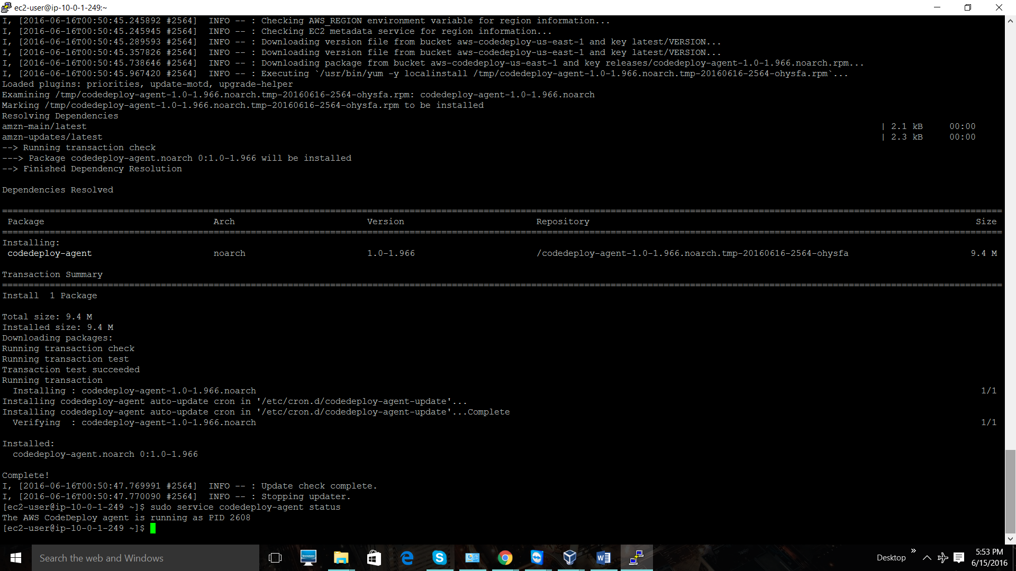

Do the same in all instances.

**Step 4**.

Now we need to create a CodeDeploy application. Go to AWS Comsole and navigate to CodeDeploy service. And get stated. We are doing custom deployment, so select it and process to next step

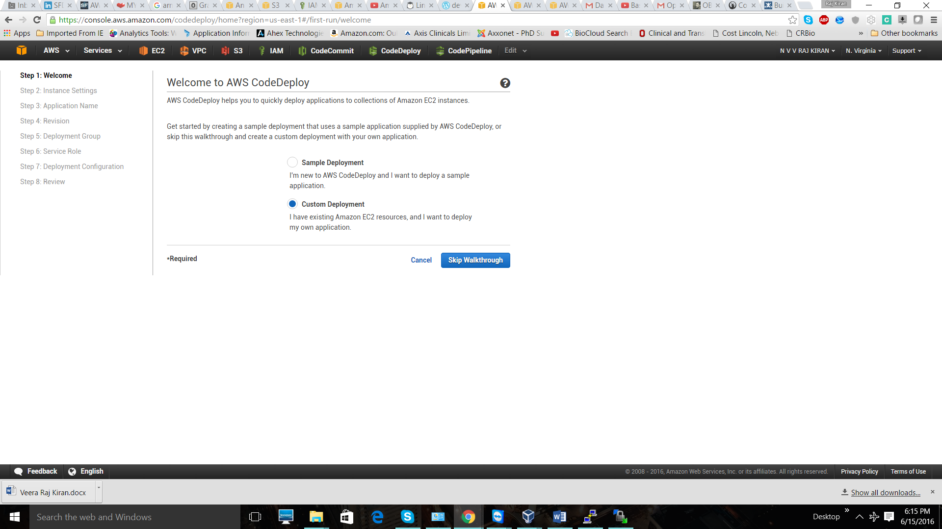

Name the application and select the instance group that you created.

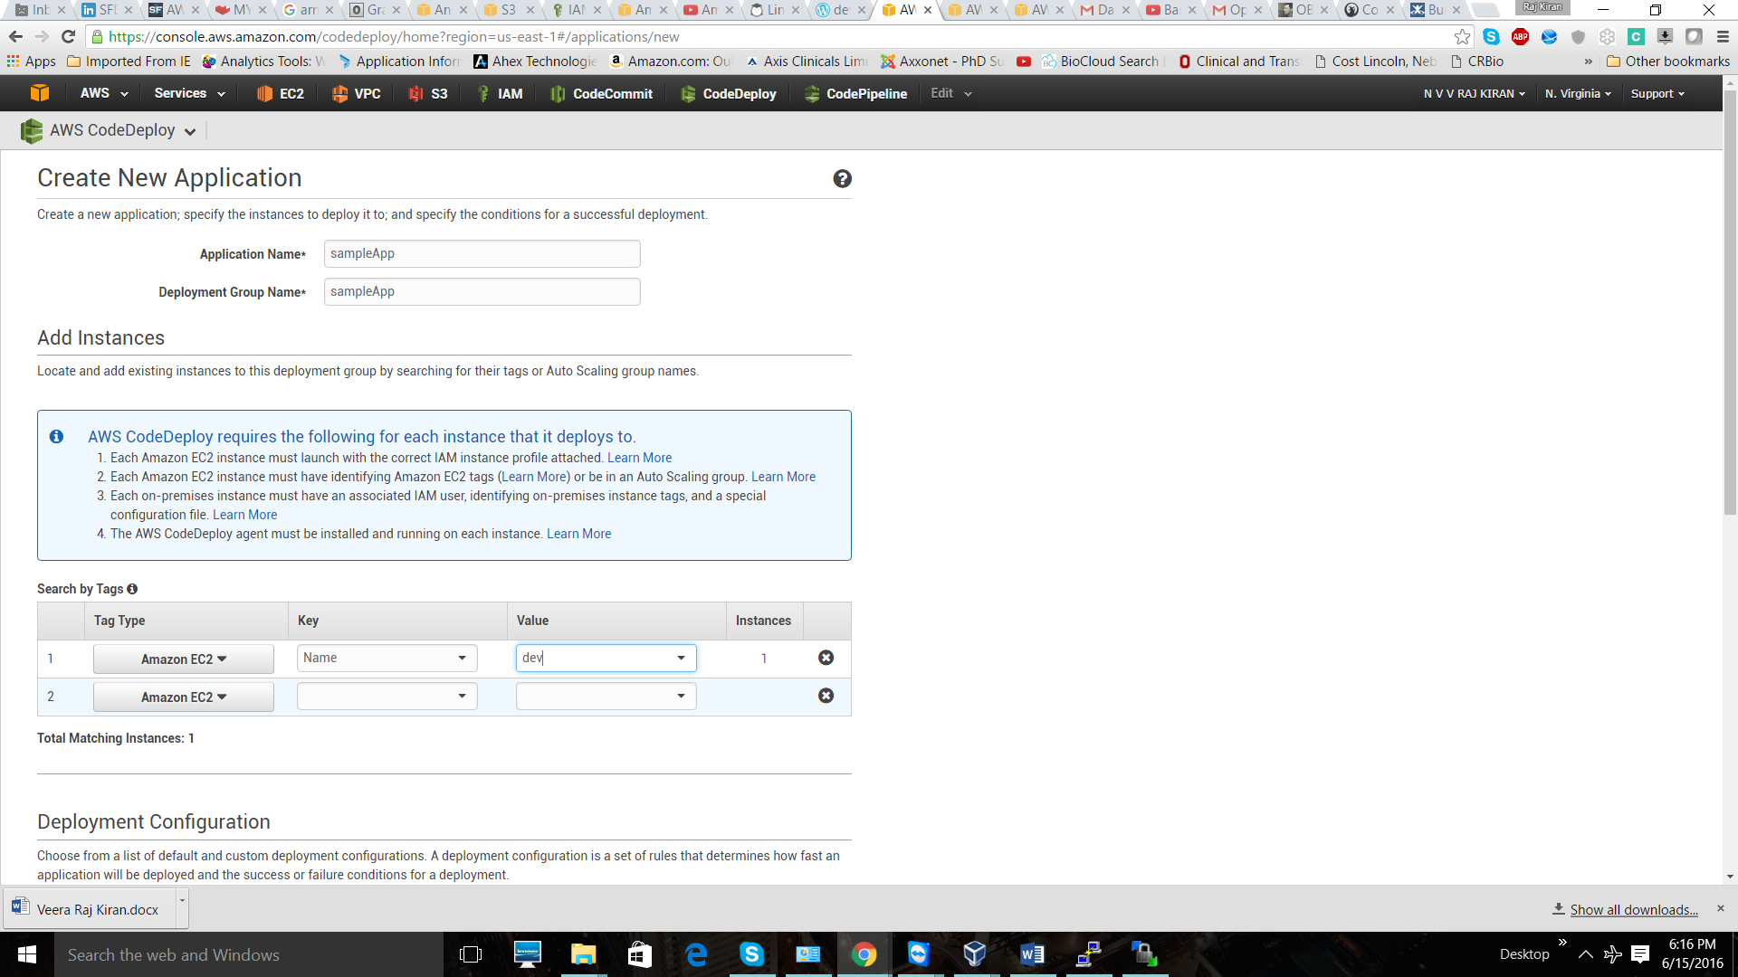

Select the Deployment configure. For now, we are selecting “**CodeDeployDefault.AllAtOnce**”.

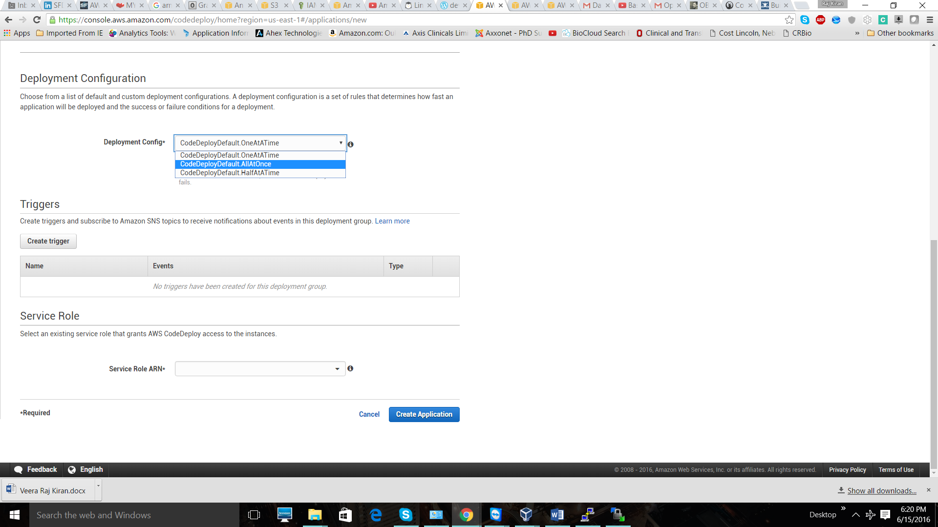

Select the “CDServiceRole” that we create initially. And create the application.

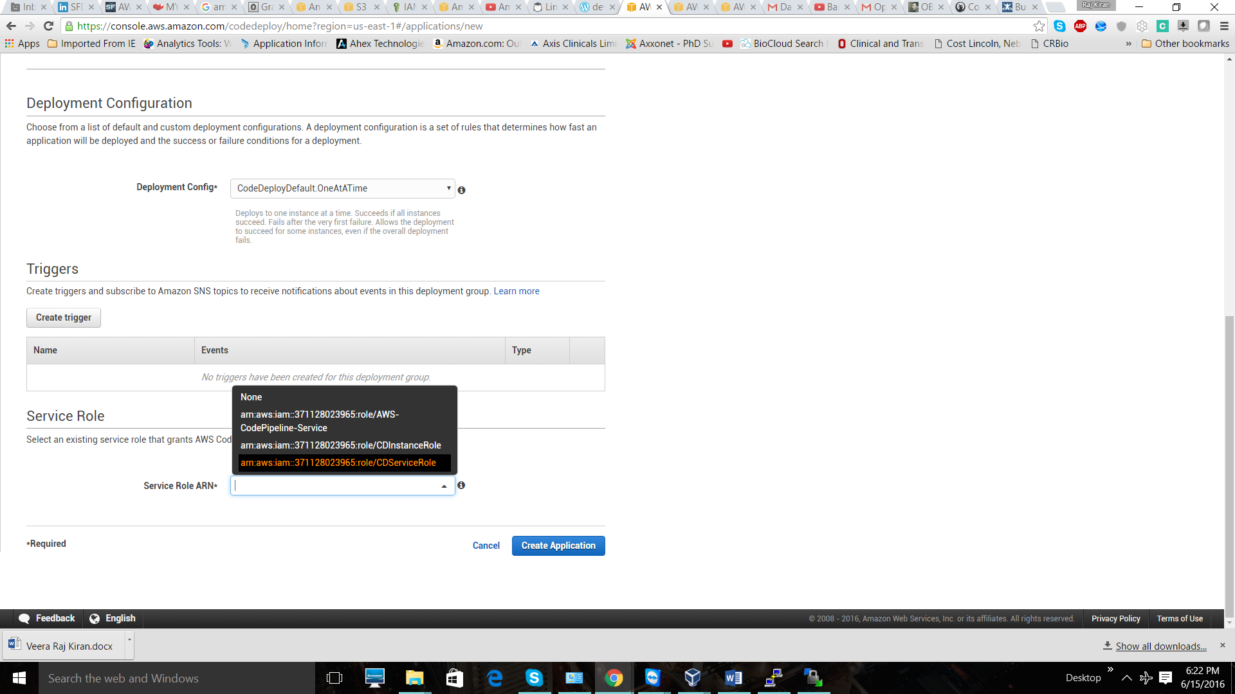

Now we are ready create a pipeline and deploy.

**CodePipeline .** Get started with creating CodePipeline.

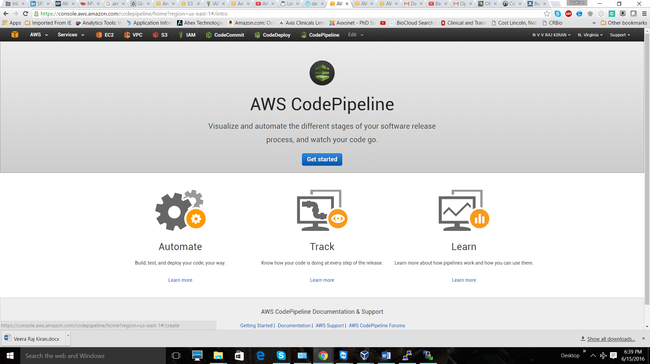

Give our pipeline a name.”Samplepipeline”

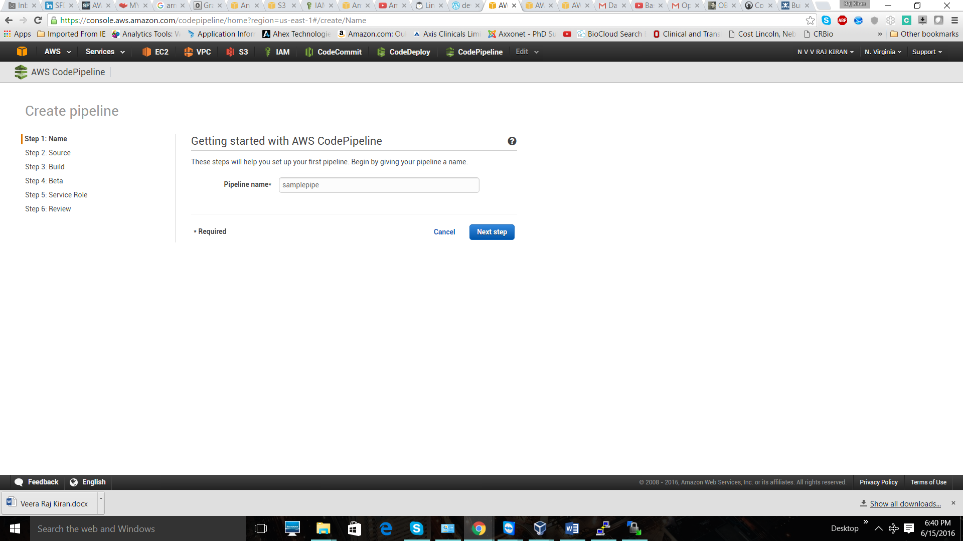

Select the source location. As our source code is in CodeCommit, I am selecting AWS CodeCommit as my source. Select the repository name and branch that we are working on.

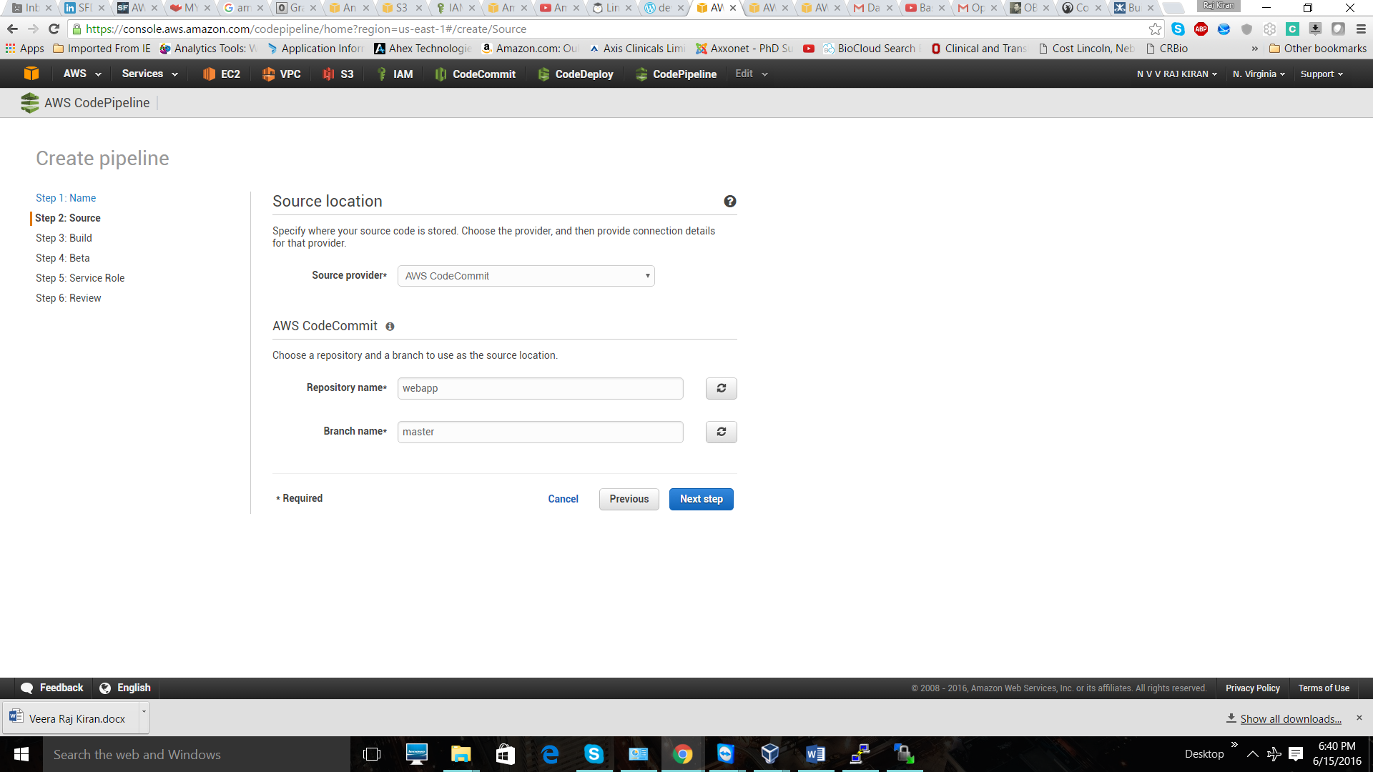

In next step we need to select the build source. We can add build step to the pipeline by configuring build server like Jenkins, we can pass those builds to the pipeline. Right now I am not adding build step, so I am just adding “No Build”.

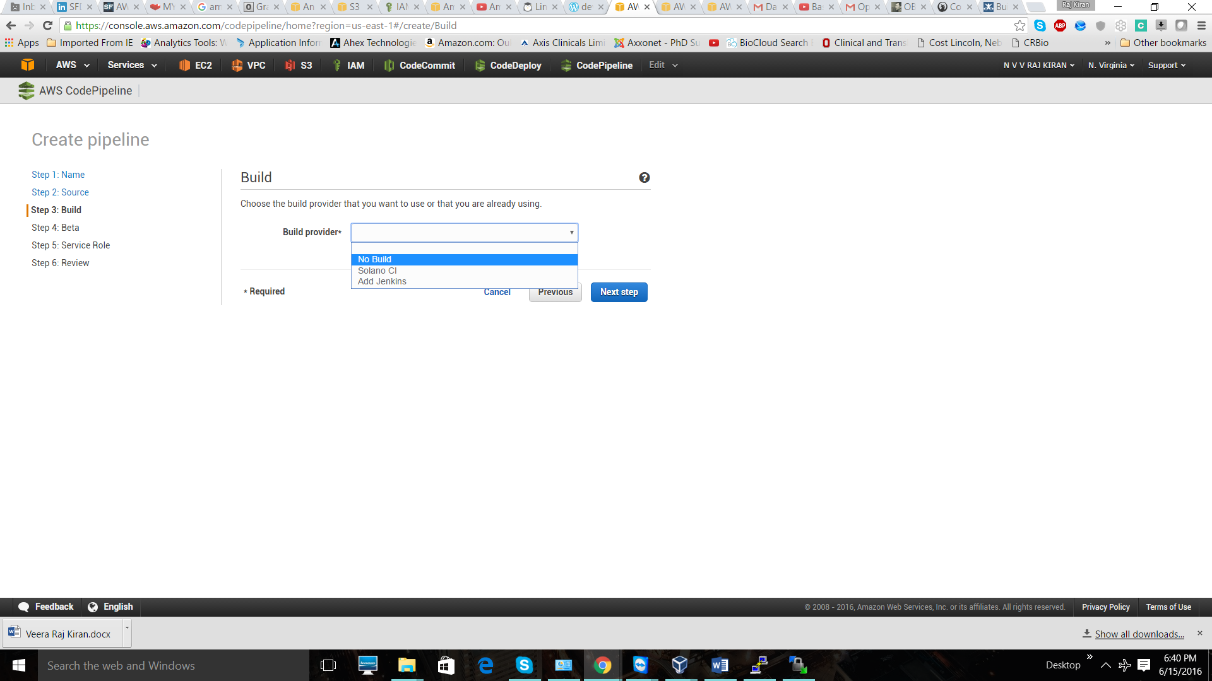

Next step is to select the deployment provider. Here we have three choose, like OpsWorks, Elastic Beanstalk, CodeDeploy. We are using CodeDeploy as the provider, so select it.

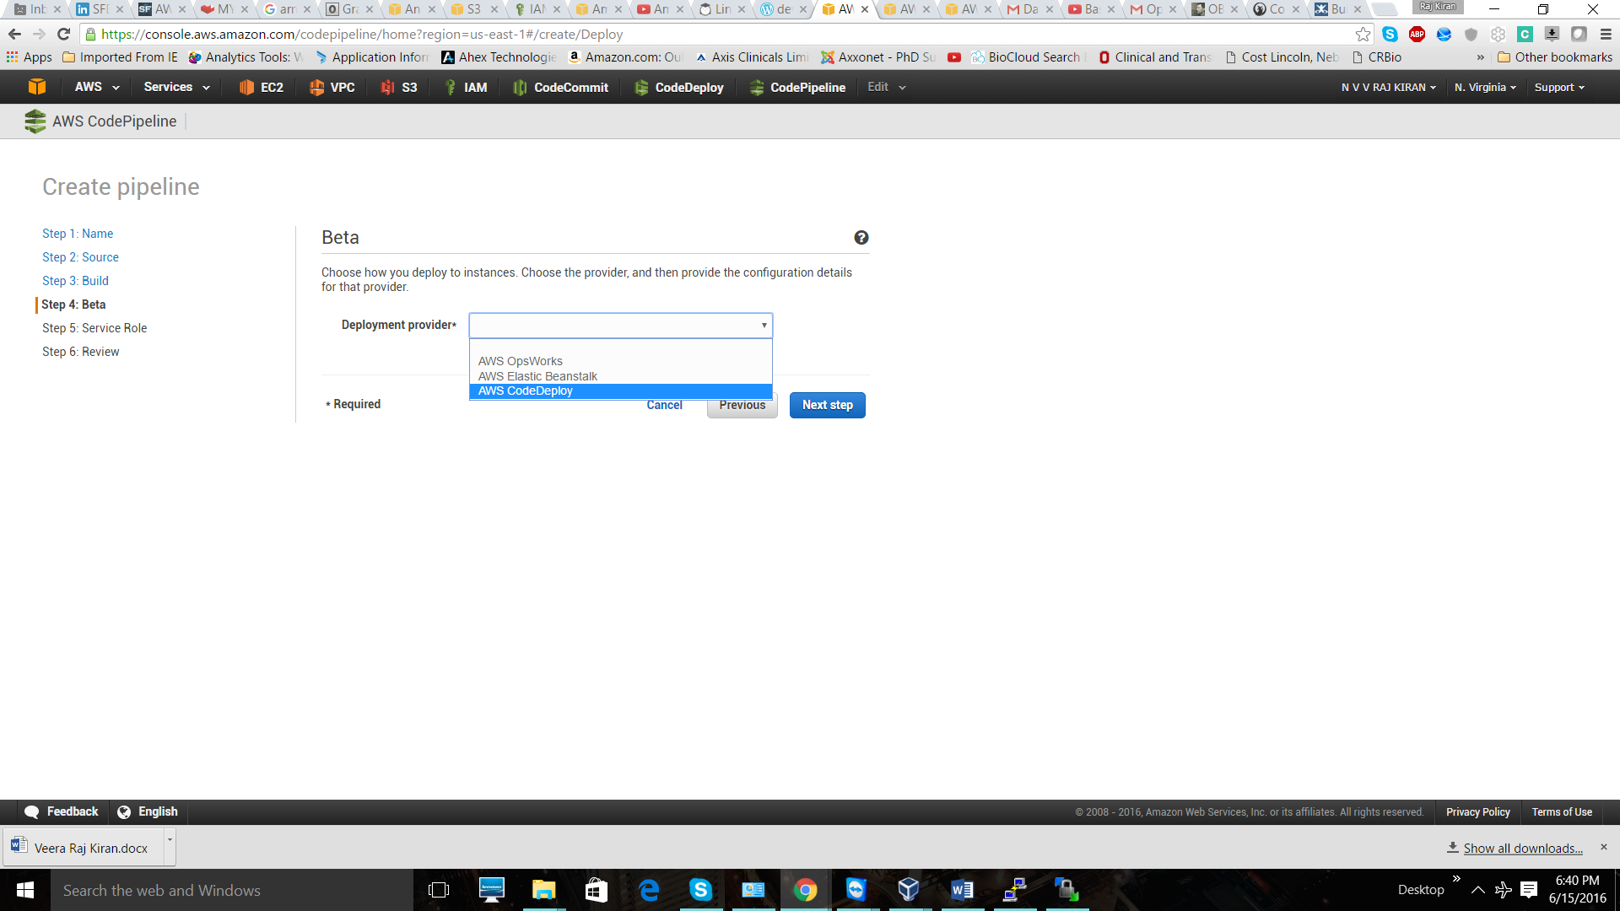

In the same step you will be prompted with application name and deployment group; select those related to our application.

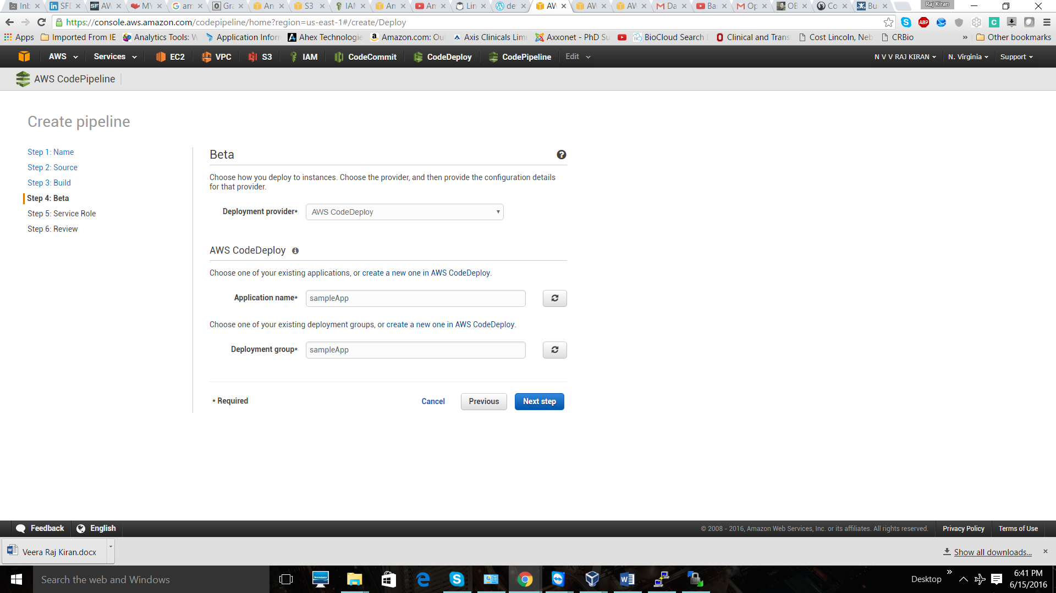

Next step is to select the IAM role for CodePipeline. We can create role there itself and associate it with our pipeline. So select “Create role”. Create a new role and attach it to our pipeline.

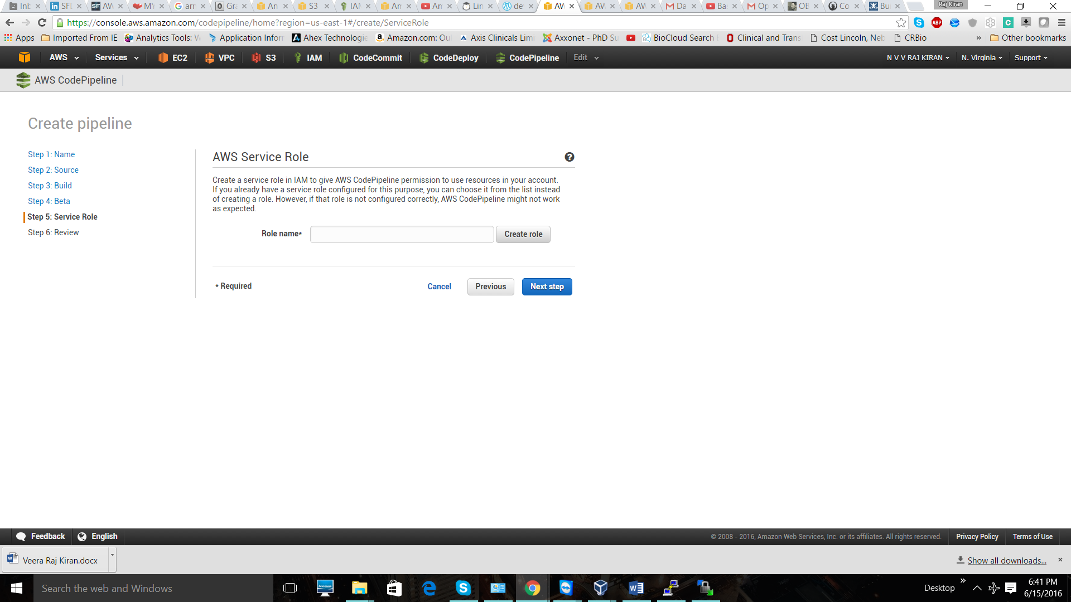

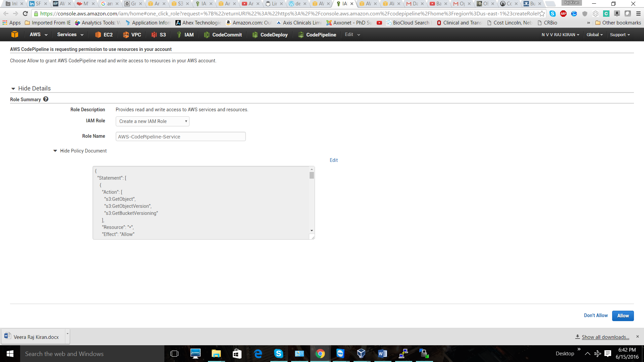

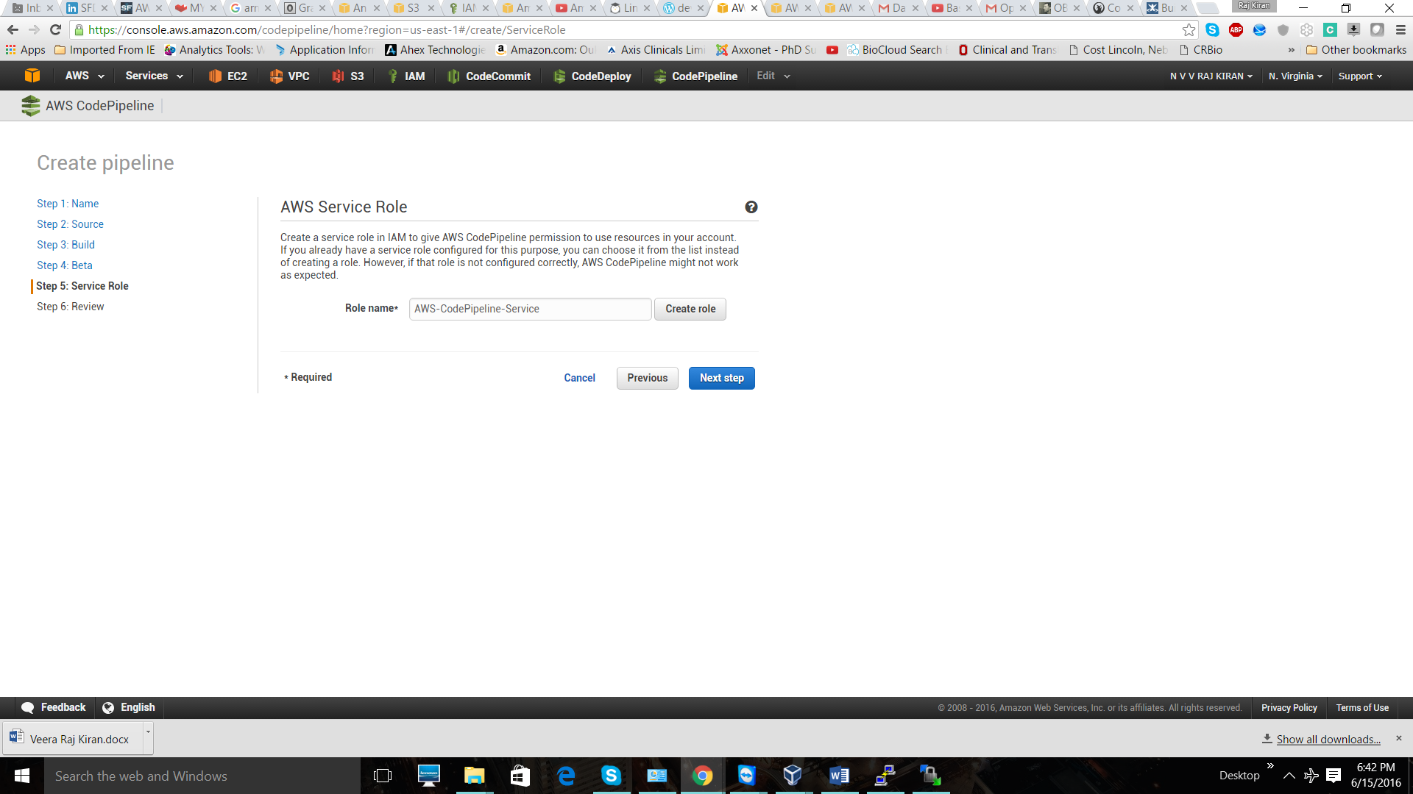

Now we are done with configuring the pipeline. Just create the pipeline. You can see the pipeline we created and we need to wait for some time to execute. It will take around 2 to 3 minutes, depending on our application. Once your pipeline is executed, you should see that pipeline turn to green, as shown below.

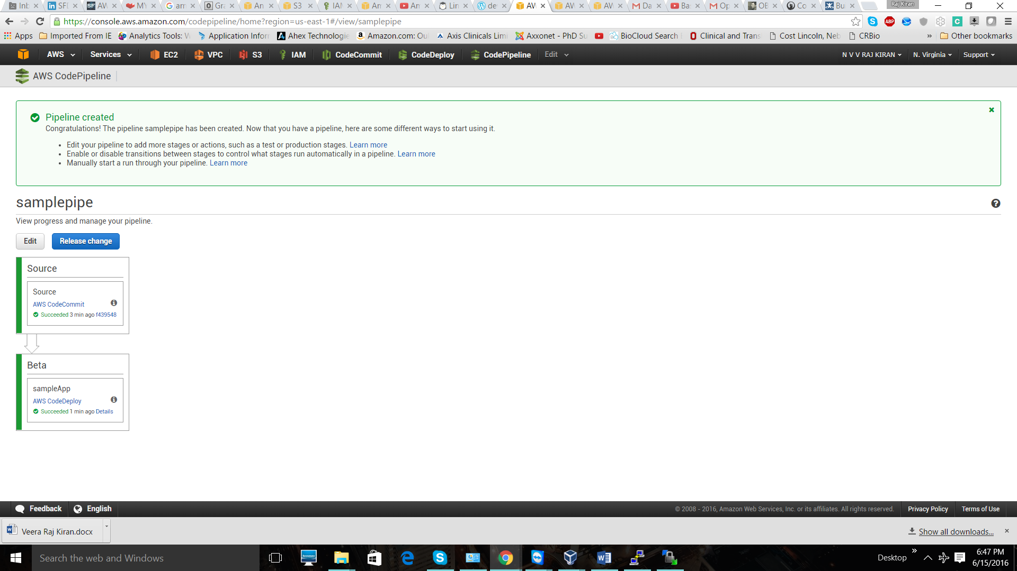

Got to search engine and enter the elastic IP of the instances. You should able to see webpage.

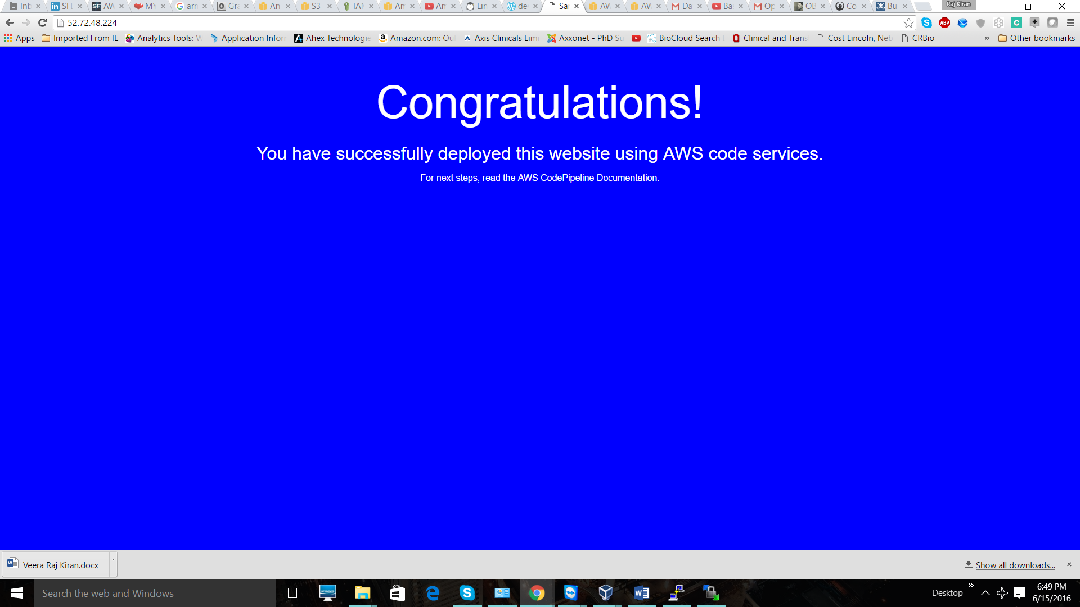

We can say that we created our application successfully and deployed across multiple instances using CodeCommit, CodePipeline and CodeDeploy services.

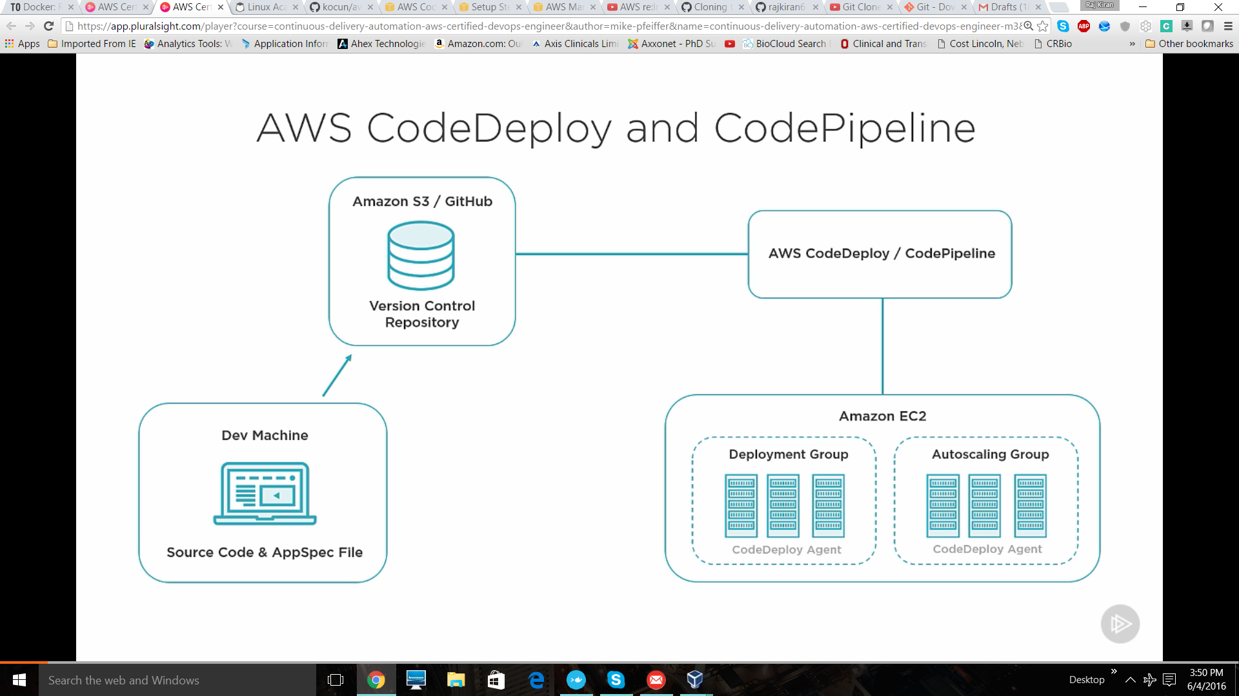

**Steps**

Become a root user.

Add the code to your Git repository or Code commit repo.

Add IAM role for code deploy. Go to IAM 🡪 Roles 🡪 Next 🡪 Select Amazon EC2 🡪 select “AmazonEC2roleforAWSCodedeploy”

Similarly Go to IAM 🡪 Role 🡪 Next 🡪 Select Amazon Codedeploy role 🡪 create it.

We are going to use this role during instance creation time.

Create EC2 instances

* Select number of instances that you are going to bootstrap. Lets host it in two instances
* Attach the role that we created first, to the instances. i.e EC2roleforAWSCodeDeploy
* In security groups .. Add new security group which allows both “SSH” and “Http” protocals, and open to the internet.

yum install -y aws-cli

cd /home/ec2-user/

aws s3 cp ‘s3://aws-codedeploy-us-east-1/latest/codedeploy-agent.noarch.rpm’ . -region us-east-1

yum -y install codedeploy-agent.noarch.rpm

**Mean while let set up our code deploy and application group.**

Go to management console 🡪 Developer tools 🡪 Code Deploy 🡪 Create new 🡪 Name it with DemoApp 🡪 DemoApp 🡪

Search by Tags 🡪 In values, select the instance taked with “DevInstance”.

Deployment config 🡪 Select CodeDeployDefault.AllAtOnce

Sevice role ARN 🡪 Give the “CodeDeployRole” that you created before.

**CodePipeline**

Go to management console 🡪 Developer tools 🡪 Code pipleline 🡪 Get started 🡪 Name it “Pipeline” 🡪 Select the source provider 🡪 Code commit 🡪 Select the repo 🡪 And branch i.e Master

Press next step 🡪 For now we not going to choose any build provider.. Select “No build” 🡪 Next step

Select the deployment provider 🡪 Here we are using codedeploy..select it. 🡪Select particular application name and deployment group.

Next step 🡪 Select service role 🡪 Create role 🡪 It will create aa codepipleline service role 🡪 Hit “Allow” 🡪 Next step.

Finally 🡪 Create pipeline